THESE STUDENTS ARE PRESENTING TO NORTH ADAMS PUBLIC LIBRARY STAFF ON MAY 10TH:
Ready, Set, Study!
Nicole Superneau (nicolesuperneau@yahoo.com)
Did you know that the North Adams Public Library is turning into a study-free environment? It is a study free environment because it is too noisy, disruptive and unbearable. I propose that we construct a room on the third floor of the library dedicated specifically as a place for studying for people aged 13 and over. With the new studying environment, high school students will be more likely to take advantage of the resources that the library has to offer. Are you willing to be involved? What you can do is inform your friends and family about the new studying environment and/or donate furniture to make our new study area comfortable and a desirable place to work.
Let’s Read!
Heather Morris (heather77970@gmail.com)
Did you know that in a recent study teenagers showed the largest decline in active reading? This is a problem, because reading helps kids focus and learn. By attracting teens to the library through outdoor picnics and poetry or short story readings, we could change teens’ views on reading. If we could get donations and cooperate with Develop North Adams, we could afford benches for the lawn of the North Adams Public Library to jump-start the movement toward literacy in North Adams.

Proposals for a Better North Adams

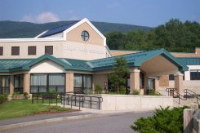

Drury High School
Ms. Quirk’s
Ninth Grade
Honors English Class
Spring 2012
About the Project:
Why? As an educator, it is my goal to make learning applicable to “real life.” In addition to research, writing, and presentation skills, it is important for students to become thoughtful, analytical, and responsive thinkers. This project was intended to address those skills in a meaningful, personal way.
What? In addition to our regular literature curriculum, my honors students spent the year exploring what elements create identity for individuals and for societies. They explored the influence a society has on an individual’s identity and vice versa. They began with themselves, being thoughtful about what makes up their personal identities, creating identity boxes and other works of art and writing. Moving outward, students attended the Children of the Mill exhibit at the Eclipse, during which time they wrote “I Am From” poems from the point of view of former child laborers at the mill. They learned from historians Joe Manning and Paul Marino, and they learned from artists at the Eclipse including, but not limited to, Ralph Brill and Phil & Gail Sellers.
Then students selected an area of focus for their research on North Adams. Students conducted reliable research, utilizing not only the local history in our own public library, but the Internet and interviews with area experts as well. They compiled this research into well-crafted, accurately cited research papers.
Looking forward: Finally, students were asked to consider all that they’d learned and to ponder the question: what would make North Adams even better? How can I create a more positive future for my city? Each student came up with a proposal for bettering North Adams. Some students worked in pairs or teams. They presented to each other and, as a class, voted to determine which proposals would appear before the city council.
In this brochure, you will find the “elevator speeches” of each project generated by our students, along with the name of the proposed project, the originally designed logo, and the name/s and contact information for the student/s who authored the project.
Thank you so much for being a willing audience for these amazing students. I hope their ideas inspire you as much as they have inspired me.
Sincerely,
Melissa Quirk

Before There Was a City, There Was a Fort
Kirby Bryce (kirbbryce48@gmail.com)
Nick Trombley (ntrombley11@gmail.com)
Jake Tatro (jakemtatro@gmail.com)
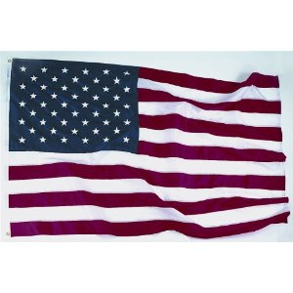
F
M
Have you ever heard of Fort Massachusetts? Many people have not. What if I told you that we have a way to educate more people about the fort and what happened there? We propose that we make a replica of the fort with the help of surrounding schools. We could get volunteers and support from McCann, Drury, Williams College, and MCLA. They can help with both fundraising and building the fort’s replica. The volunteers could earn school credit for the work they do to help with fundraising and building. With this volunteer work, this should not have an overwhelming cost, and the money that we actually need, can come from grants. With this help, everyone will know that “before there was a city, there was a fort.”

Touring through the Past
Audrey Johnson (johnson6audrey@gmail.com)

Have you ever been bored in North Adams? Are you interested in paranormal activity? Would you attend tours through a claimed haunted building? There are claimed to be four ghosts haunting the Houghton Mansion. If there were regularly scheduled tours, it could have huge benefits for our city, including providing job opportunities and attractions for tourists as well as local citizens. This project would keep kids off the streets and learning and digging into North Adams’ history.

Art is the New Future
Emma Waryjasz (d1208olphin@gmail.com)
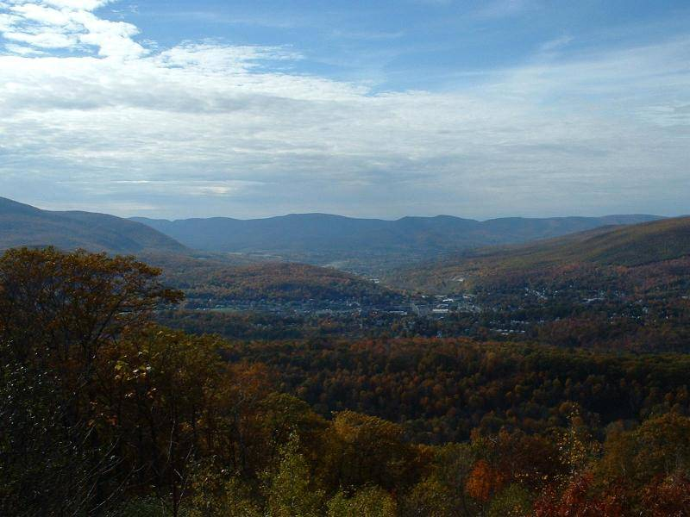
Art is the Future
of North Adams
Did you know that the Eclipse Mill was one of the most booming businesses in North Adams in the early 1900’s? It was home to many well-known businesses, but was transformed in 2002 into beautiful homes and studios for artists. Unfortunately, there seems to be a divide between the artists and area residents. To help our city become closer together, I propose that art by the Eclipse Mill artists be displayed downtown to show how the city has pride in its citizens. I also propose art classes to be held by the artists of the mill for the public to engage and express artistically and bring the community closer together. With your help in making this come true, our citizens will become closer together and have even more pride in their city.

A New Western Gateway (Hoosac Tunnel)
Alex Candiloro (candiloroalex@gmail.com)
Nicholas Mirante (mirantenick@yahoo.com)
Thane Preite (tpreite@yahoo.com)
Schuyler Robinson (robinson.schuyler@yahoo.com)
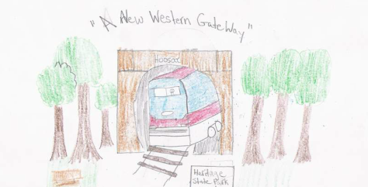
Did you know that 192 workers died in trying to build the Hoosac Tunnel? The Hoosac Tunnel was once the largest tunnel in the world. The workers who gave their lives deserve a memorial, and residents of North Adams deserve an improved entryway to the tunnel. Right now, graffiti, rust, and other types of vandalism have made the once beautiful tunnel look like a dump. We should have a memorial park for the tunnel that has hiking trails, benches and places to eat. We should have a memorial (PLAQUE? STATUE?) to recognize the men lost in its construction. Can you volunteer time, money or resources to help us accomplish this?

Hoosac North Adams: A Portal to the Future
Kyle Clairmont (k.j.clairmont@gmail.com)
My idea is to celebrate the completion of the Hoosac Tunnel and North Adams by holding a celebration at the entrance of the tunnel itself. There will be music, food, and it will be a lot of fun. We will sell t-shirts and lanterns and have an amazing event. It will last 24 hours, starting July 1st at 1pm. This will celebrate the 136th anniversary of the tunnel.

Houghton Mansion
Hannah Rivard (hannsterrr@aol.com)
Did you know that the Houghton Mansion once housed our first mayor? It was built in 1897 and is still standing today. However, many people have never seen the inside of it, or even know about its history. I’m working on making the Houghton Mansion a top tourist attraction in North Adams. I would like to refurnish the building and give tours weekly. With the right supplies, we can restore this building to its former glory. Would you like to contribute? You could help by donating supplies or volunteering your time.

Where Entertainment is at Its Finest
Justin Girard (justingirard20@gmail.com)
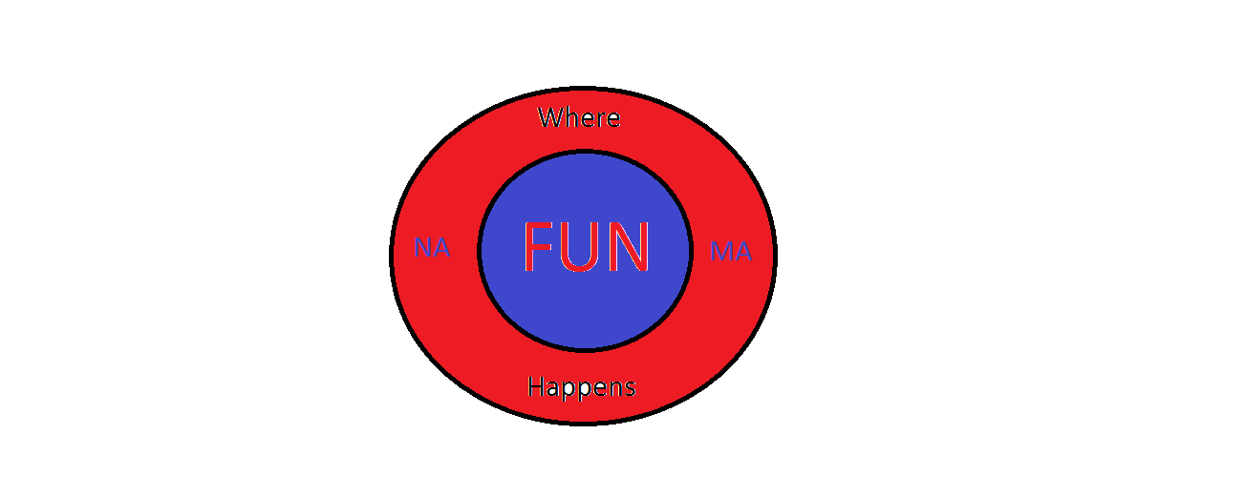

Is there a lot to do in North Adams? There’s not, but I can help with that. I am from Drury High School and have been researching our economy. I have come to the conclusion that we need a laser tag arena. It’s fun, affordable, and will boost our economy. It will only cost $10,000-$50,000 to start. This may seem like a lot, but it is projected to earn around $60,000/year. North Adams has many ideal spaces for the arena. Here’s what you can do: put money down on the idea so we can have more entertainment and an additional source of income for our city.

The Route of Art
Daelyn Peterson (dummybear7627@aol.com)

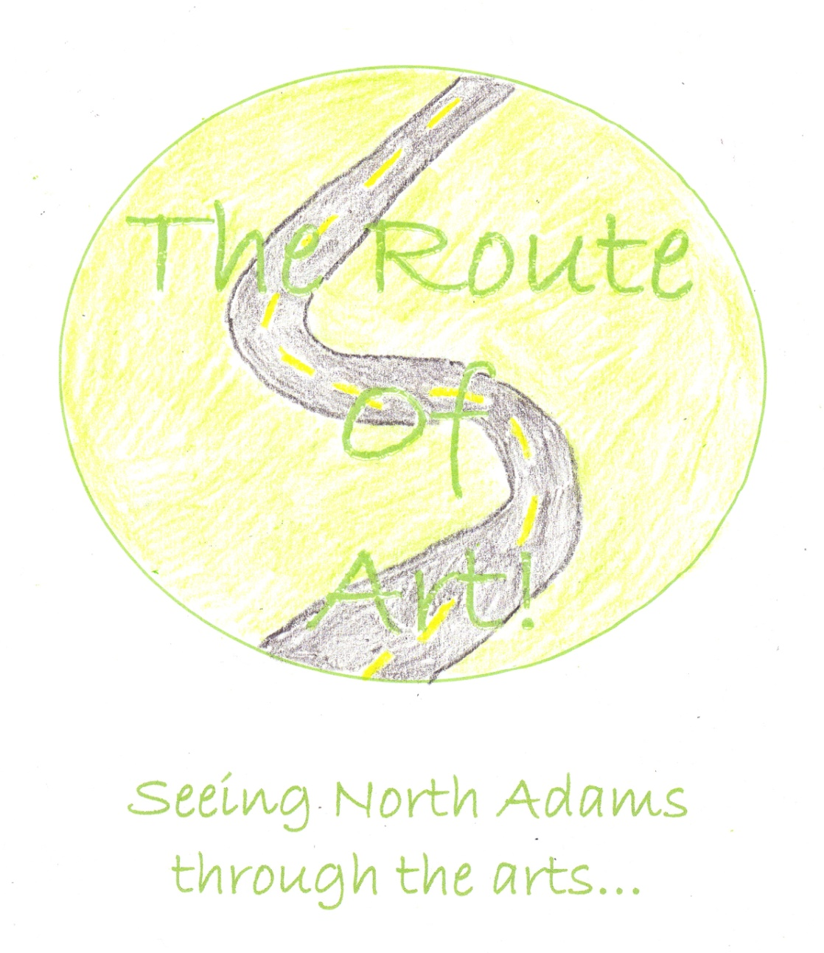

Did you know that Mass MoCA, one of the largest contemporary museums in the world, is in North Adams? I propose that a “Route of Art” be created. The route would consist of sculptures created by artists from Mass MoCA and community members. These would be placed in the downtown area and people could follow a map to take a tour to see them. The sculptures will be made out of materials donated by local businesses. The “Route of Art” will benefit the community by increasing tourism, income, and community pride!

Youth Matters!
Cain Laikind (cainlaikind@yahoo.com)
Did you know that only 24% of voters aged 18-29 vote in presidential elections? It’s up to them to elect future leaders, so they need to be educated. I’m currently planning the “Youth Matters” program. This will educate young adults in the workings of politics as well as individual candidates. The classes will be public and free of charge. Political figures could visit and give speeches to the class in order to inform the higher concentration of voting young adults. You can help support the project by sending the mayor a letter.

Revitalizing the Hoosic River
Michael (Sully) Boland (bolandmichael72@yahoo.com)
Did you know that the Hoosic River was once a great power source to the economy of North Adams? In fact, the river was once a pwer source to the thriving mills and factories in North Adams. The river was a very important resource to the city and now it has little purpose at all. This needs to change. My idea is to make the river an eco-friendly power source for businesses and residents of North Adams. This can be done by purchasing hydro-electric power generators. Although they are expensive to purchase, they pay for themselves over time. Let’s make the river an important aspect of our community once again!

Keep the Heritage in Heritage State Park
Matt Scanlon (mattscanlon48@yahoo.com)
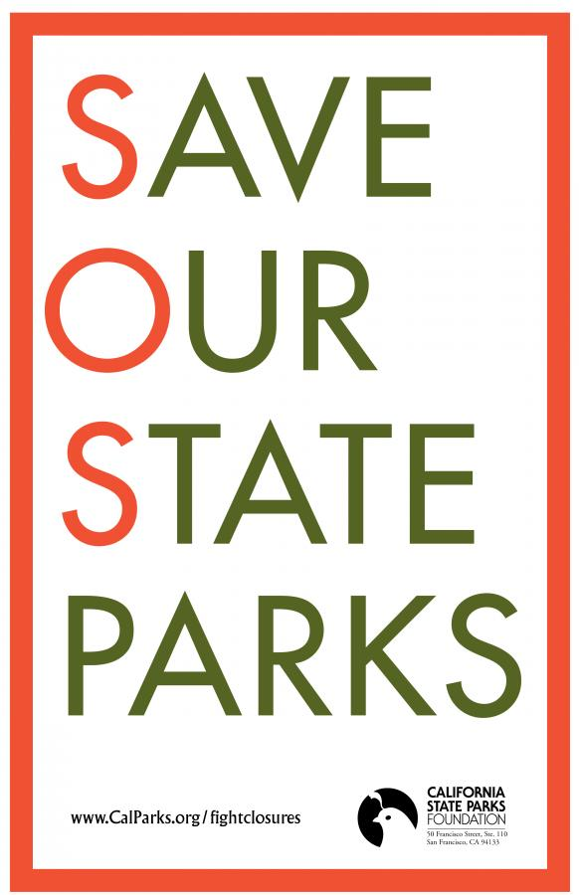
Let’s Keep the Heritage in Heritage State Park!
As you know, it is bad business to buy a broken-down property. And as you know, the city can no longer support Heritage State Park. We must fix up Heritage State Park in order to protect our history and legacy. This includes information on how the city was founded. One way of doing this would be to set up donation center to fund a project to fix the roof so that an outside business would be interested in buying the property. A more beautiful park will mean more likely for a business to invest in it. You can help support the program by giving funding to buy the donation boxes, or by making a donation yourself.

Get Voters Educated
Josh Girone (giro521@gmail.com)
Jesse DiLego (jdilego6@gmail.com)
Did you know that most voters don’t study enough of their candidates before elections? We hope to change that. We want to change the way people vote so that voters know what they are voting for. With this, we can ensure that people are voting for what they really believe, because they will understand enough to know if they truly agree. We would like to let younger voters understand and know what candidates are talking about before they just write down a name; AND we want to make sure that they do vote! We will do this by educating and advertising when and where to get information. It would be great if you joined us to help them understand politics better!
Come Together and Be the Star You Are
Kyra Hayes (kyralhayes@gmail.com)
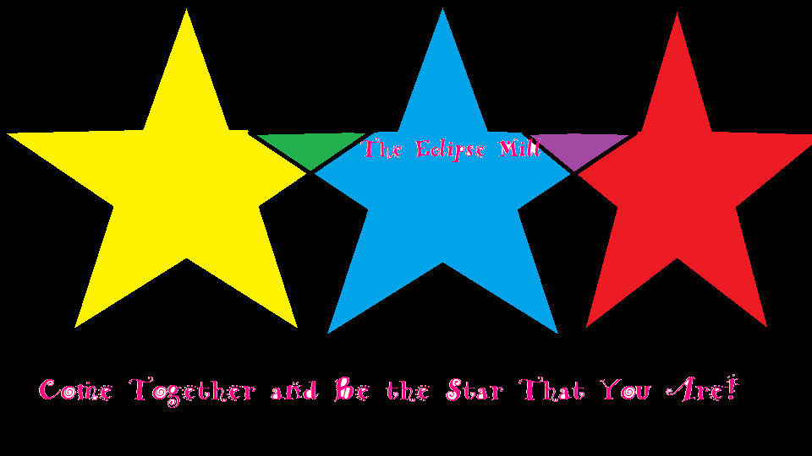

The Mohawk Theater
Destiny Martin (destinymartin7@yahoo.com)
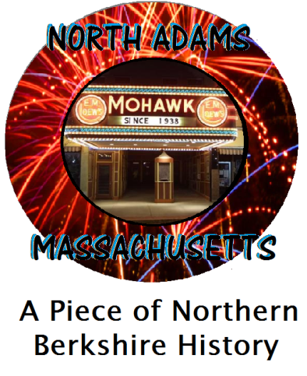
With the Mohawk Theatre reopened, there will be more job openings and the economy will rise. My goal is to have a two-day fundraiser for the Mohawk Theatre that helps celebrate its 75th anniversary. The Saturday event will be a gala event, by invitation only, with a wine and cheese reception, silent auction, and viewing of the first movie ever shown at the Mohawk. Sunday will be a community event with a bake sale, Chinese auction, and several viewings of the movie for low admission cost. If you want this historical movie theatre to reopen, here’s what you can do: help make this fundraiser happen! Donate money or items for the auction/s, volunteer time, and/or come out to the event to celebrate and have fun!

Medicine in North Adams
Becky Durant (bmdurant47@gmail.com )
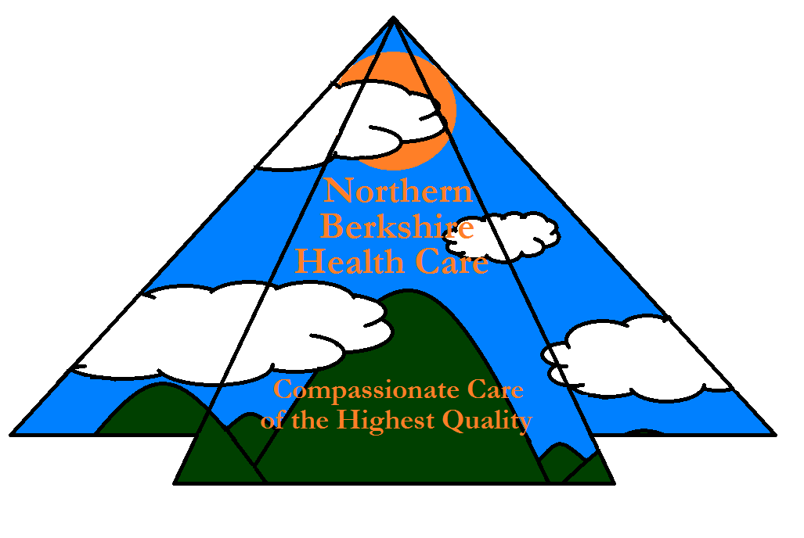

My goal is to improve the efficiency in the Emergency Room (ER) at North Adams Regional Hospital and make North Adams a healthier place. The ER has low efficiency because it is becoming harder to find primary care doctors and more people are coming to the ER for less serious problems, crowding the ER for more serious cases. I want to designate a few rooms of the ER to a clinic to help people with less serious problems. This will improve the ER efficiency by letting more serious patents in for care faster, and the less serious out quicker. You can help by running fundraisers for the extra staff needed for the clinic.

Catching Eyes with the Mohawk Theater
Destiny Crews (destinycrews@gmail.com)
Catherine Marceau (catherine_marceau@yahoo.com)
Renee Sherman-Gauthier (reneegauthier15@yahoo.com)
North Adams once had a booming and interesting downtown. We are hoping to restore a piece of downtown. We CAN accomplish this by re-opening the Mohawk Theatre. With fundraising, donations from local businesses, and enthusiasm, this is a feasible goal. It’s already a work in progress as a collaborative effort with MCLA. In addition we could open the theater for movies, which would create jobs, entertainment, and expose generations in the future to what they’ve missed out on. Let’s get it started by making a community event. We’d love to create a theater related scavenger hunt to begin the theater’s renewed excitement. There will be benefits that can and WILL be attained if you’re on board with us!

